DG 18 (B 25 d. 22.09.09) Forside  5 Cladosporium, 2 Aspergillus (ret: P C) | DG 18 (B 25 d. 22.09.09) Bagside  5 Cladosporium, 2 Aspergillus (ret: P C)  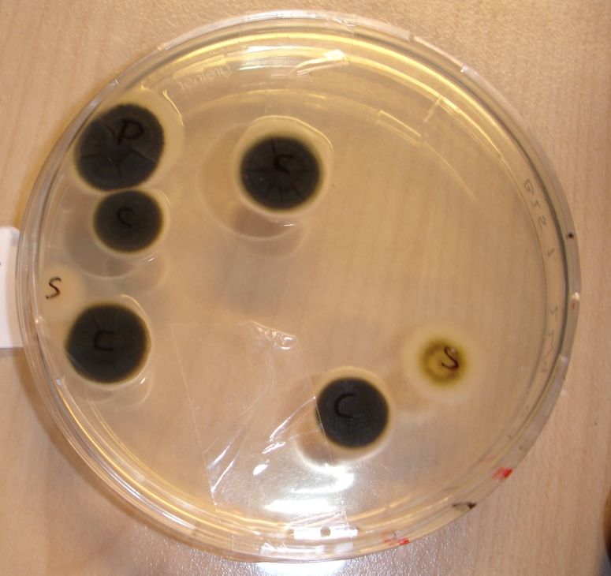
V 8 (B 25 d. 22.09.09) Forside  7 Cladosporium, 1 Aspergillus, 2 Penicillium  3 Gærsvampe  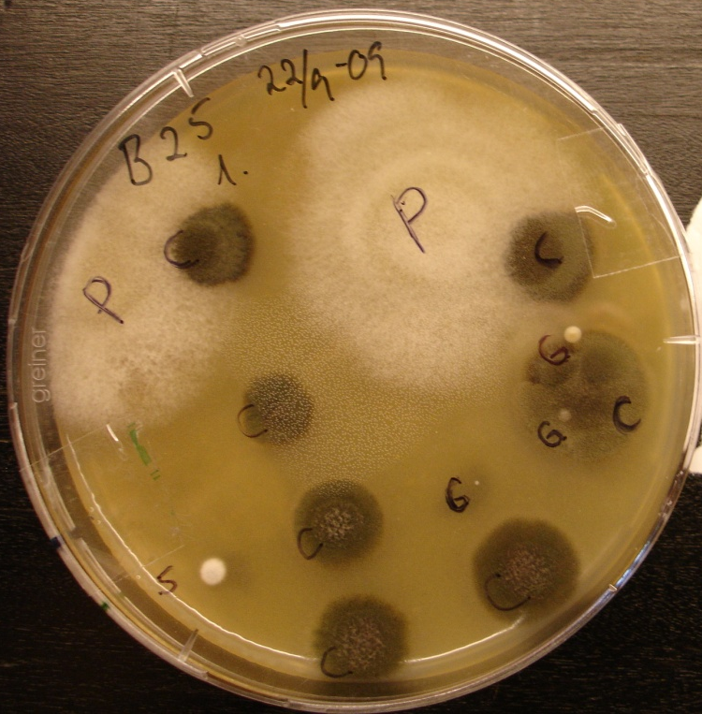 | V 8 (B 25 d. 22.09.09) Bagside  7 Cladosporium, 1 Aspergillus, 2 Penicillium  3 Gærsvampe  